# **Assignment 07**

# 7.2. Develop a thorough system model for wilderness weather station case study.

**Functional Requirements for Wilderness Weather Station and model diagrams are mentioned below:**

1. The weather station system will collect weather data from instruments periodically.
   1. Each station will measure and collect weather parameters from instruments.
   2. Data of the wind speed and direction, the ground and air temperatures, the barometric pressure, and the rainfall will be measured over 24-hour period.
   3. Software system will collect parameter readings periodically (for example, temperatures are measured every minute.)
   4. Manage data and Perform initial data processing. For instance, Temperature measuring instrument will provide value in Voltage. The software will convert it into centigrade temperature using this formula: [(analog voltage in mV) - 500] / 10
   5. Transmit collected data to data management system.
2. The data management system collects the data from all of the wilderness weather stations, carries out data processing, analysis and archives.
   1. The software will convert collected data from sensors into understandable values using suitable formulas.
   2. The system software will be responsible creating and managing databases.
   3. The process includes acquiring, validating, storing weather parameters.
   4. The data is processed in a form that can be retrieved by other systems, such as weather forecasting systems.
3. The station maintenance system will communicate with all weather stations and monitor the system health and report back.
   1. Establish communication over satellite link and ensure transmission of information when requested by the data collection system.
   2. Store information if communication fails and maintain data locally until communication is established again.
   3. Run regular diagnostic tests of the overall system, Monitor the instruments, power, and communication hardware and report faults to the management system.
   4. Manage the system power, ensuring that batteries are charged whenever the environmental conditions permit but also that generators are shut down in damaging weather conditions, such as high wind.
   5. Allow for dynamic reconfiguration where parts of the software are replaced with new versions and where backup instruments are switched into the system in the event of system failure.

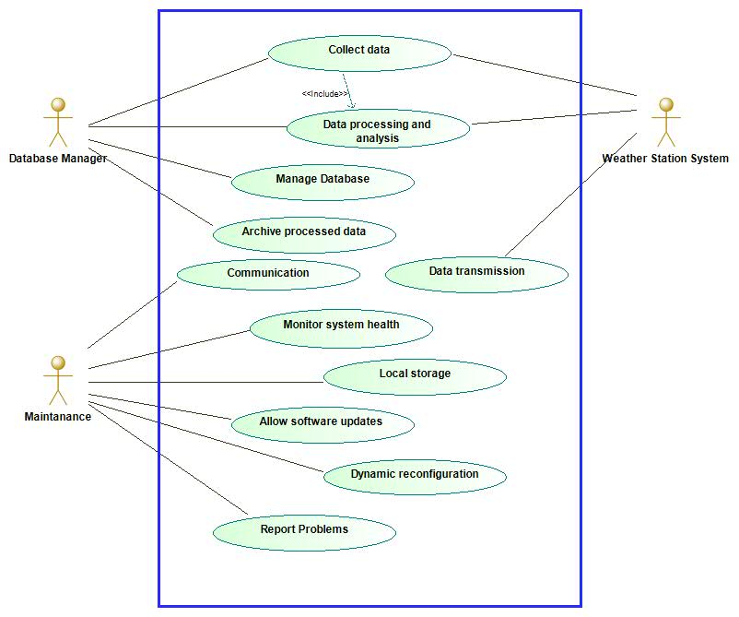

Figure: Use Case Diagram

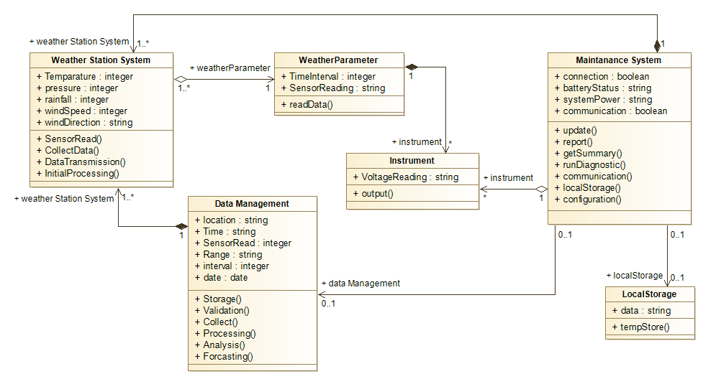

Figure: Class Diagram

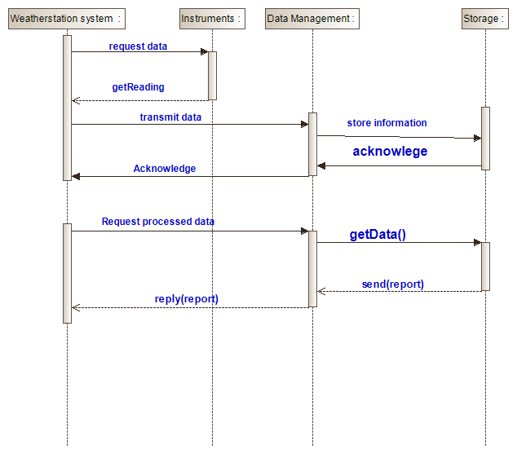

Figure: Sequence diagram